03/01/2017

- When we click on 'S10',we will get the report showing the last matches played by the 2 teams, bets placed on them through punters.

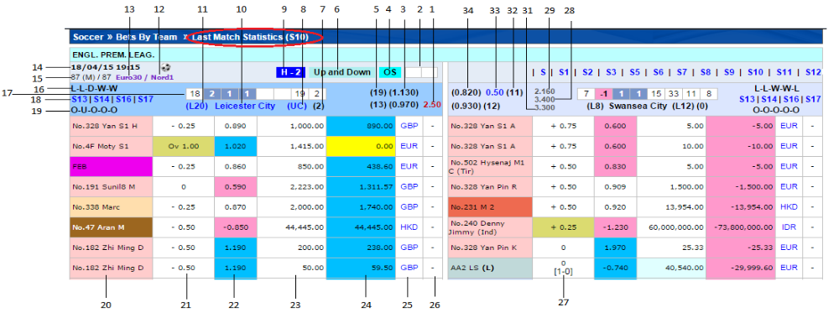

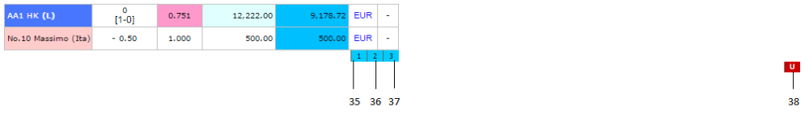

# | Header | Info
1,3,33,34 | - | Explained in MSI - 03
2,4,6,9 | - | Explained in MSI - 02
12,13,14,15 |  | Explained in MSI – 01
5,32 |  | Explained in TSI-03
7,8,10,11,17 |  | Explained in TSI-02 and TSI-03
16,18,19 |  | Explained in TSI-01
20 |  | Smart Group - Last 12 Months Performance
21,27 |  | Handicap - Smart Group last 50 bets
22 |  | Price – Smart Group League Performance
23 |  | Stake
24 |  | Win/Loss
25 |  | Currency - Smart BBG Pending Bets
26 |  | Smart Group last 12 days performance
28,29,31 |  | Explained in MSI - 02
35 |  | Handicap Trend (Blue if npricecolumn <= 3 else Dark Blue). -npriceColumn calculation given below.
36 |  | Handicap Trend as above
37 |  | Handicap Trend as above
38 |  | Over/Under Trend (If TrendType is OverUnder and nPriceSide =1  then Red O and if nPriceSide=2 then Red U)

How to calculate nPriceColumn:
In Trend setting constants are assigned the following values in cc_object.js

Trend Settings | Handicap | Over/Under
Spread | 0.075 | 0.1
MovePoints | 5 | 7.5
BreakPoints | 20 | 20

Calculation of Trend Info (calculateTrendInfo) actually generates three values (nPriceSide, nPriceColumns, nBreakPoints) in the method which will be used in the ccht_object.js to build the trend table.
nbreakPoints is 20 for both HDP and Over/Under as shown in the above table.
To calculate nPriceSide and nPriceColumns, following data is required from the match statistics:
dBetPrice - Price for that bet type. This gets convereted to HK based on the oddstypeId.
nselectionId-Selection of the team.
aopenPrice- Opne price for A team
bOpenPrice- Opne price for B team

Condition:
if (nSelectionId == 1)
if(dBetPrice > aOpenPrice)
-nPriceSide = 2;
-dBetPrice = dBetPrice – aOpenPrice;
if (dBetPrice < aOpenPrice)
-nPriceSide = 1;
-dBetPrice = aOpenPrice - dBetPrice;
if(nSelectionId == 2)
if(dBetPrice > bOpenPrice)
-nPriceSide = 1;
-dBetPrice = dBetPrice – bOpenPrice;
if(dBetPrice < bOpenPrice)
-nPriceSide = 2;
-dBetPrice = bOpenPrice – dBetPrice;

Above calculation will give dBetPrice, then

if(dBetPrice != 1)
-nPriceColumns = (dBetPrice * 100) / dMovePoints;

Handicap Trend:
(Blue if npricecolumn <= 3 else Dark Blue). Ex: 123 123456
Over/Under Trend:
If TrendType is OverUnder
-nPriceSide =1then Red O
-nPriceSide=2 then Red U

